# Project Overview

// goal of this section

This section denotes the procedural strategies to develop this software. This analysis will help future business strategic improvement.

## Software Conceptualization

// what

// why important

// what are the advantages

1. Understanding Software Advantages

Firstly, the business analysts must understand the unique advantages of the new system. Without having a compelling reason to adopt a new practice, people will not spend the effort and time to adjust their habits. This system suppresses traditional ordering methods by the costs needed to perform the same tasks by £16,800 - £33,600 per year. Restaurant owners will not need to take, record, and deliver the orders and give and take meal's payment as customers will perform these tasks instead. Since restaurant waiters would only require taking the customers to the table and deliver the meals, they will save at least 50% of the work. By reducing the number of people needed to maintain the restaurant waitering operations by 50%, restaurant owners would save an annual staff cost of 50%. A typical restaurant will have 2 waitering staff. We could therefore help restaurant owners save an annual cost of £8 x 6 hours x 350 days = £16,800.

1. Feasibility Study

The business should conduct marketing research to assess the business scope of similar companies. The project should proceed only when the business ideas are not universal. It would be ideal to assess if this business can sustain with sufficient market gap. A brief google search suggests that there are less than 3 companies in the UK that conduct businesses with a similar focus.

1. Optimization Metrics

The company should identify ways to outperform existing practice. By understanding the metrics that determines the product's success, it makes it harder for other ventures to build a better product. The critical aspects to consider include how to keep customers to continuously using the system and will not leave; how we can grow the business internationally; and how to maintain system capability.

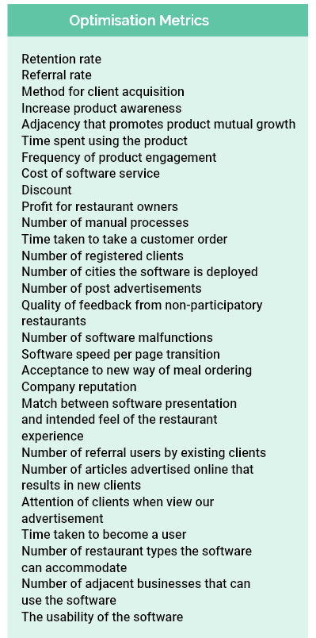

1. Business Executive Strategy

Another essential component of the business is to understand the minimal company operations for later revenue-cost analysis. Secondly, to ensure that the software is tailored according to all the critical business requirements. The goal of iterative evaluation is to prevent time lost due to redundant software development.

Following the software development,

Post marketing is

* We will send letters to all the regional restaurants then expand our user network to neighboring cities.
* Cost of post marketing is £1.5 per letter = £0.65 stamp + £0.75 (envelop+ paper+ printing)
* Use post because it guarantees that only the restaurant owner will read the letter.

1. QR code videos

* The letter will include some QR codes that redirect the restaurant owners to some product video demonstration. By letting restaurant owners to live stream our product, they are more likely to understand and appreciate the benefits of the software.
* People are generally more persuaded with video presentations than letters with words only.

1. Landing Page

* We have a web page where restaurant owners can be redirected from the letter to the landing page through the QR code. The website will demonstrate our customers the benefits of our platform and the main functions of the software.
* By using short texts and pictures, hopefully people getting into our website can understand the benefits to be a member of the platform.
* The design process also consider minimalistic representation so that visitors will not get distracted or overwhelmed with the amount of information displayed on the web.

1. Registration

* The registration portal asks the users the minimal information that will help staff register the restaurant menu to the platform. They are only required to type in 11 pieces of information. We aim to do all the tasks for the restaurant owners so that they don't need to spend any time to deal with the computer system. We will then have an automatic email confirmation system so that the system can verify the accuracy of the email address provided by the user.

1. Account Setup

* The next stage is to upload the business info and menu to the system before they can start using the restaurant sit-in ordering platform. Our staff will take care of the process to upload business info and menu. The reason it is important for company staff to register all the details is that we can review the presentation of the software platform before we confidently deliver the product to the customers. By reducing the time spent of the restaurant owners interacting with the software system, they are less likely to feel frustrated by the difficulty to learn and upload restaurant details.

1. Post QR code menu

* Once the restaurant platform is ready for production, we will print out all the QR codes and ship it to the restaurant owner. We will use laminator to protect the content of the QR code as it must be correct for the customers to get into the ordering system. The number of QR codes we will prepare depends on the number of tables the restaurant has. Since it is inevitable that they will loss some QR codes over the years their customers use the mobile app, we will create four times the number of the QR codes so that they have sufficient replacement when it is damaged or lost.

1. Successful Client Signup

* Restaurant owners will need minimal staff intervention unless they need to change some menu details or have specific enquiries.

# Database Organization v1

* Database diagram and descriptions (later)

# Design Principles

* In earlier dissertation version

# Testing Methodologies

## 